Starter Kit 2018

**Board Game Capmates**

Specification – Solution Example

**Version 1.0**

1. **Challenges and games** 
   1. **Epics and User Stories**

**Epic:** As a User I want to be able to throw a challenge at other users, arrange a meeting and save its result.

**Story listing:**

1. As a User I want to be able to see a list of thrown/received challenges so I can select one and decide whether to accept or decline it:
   * User can see following challenge lists:
     + Challenges thrown by other users,
     + Challenges automatically created by the system,
     + Challenges thrown at other users,
   * User can accept or decline a challenge and save a comment about it,
   * User can see a list of all challenges accepted by him.
2. As a User I want to be able to propose new time for the selected user to play a game:
   * User can find User by his basic profile information, owned games and ability time,
   * User can create a new challenge for selected user and send an invitation message.
3. As a user I want to save information about games:
   * User can save information whether the game took place,
   * User can add a comment about it,
   * After the game all participating users should automatically earn score points for said game.
4. As a User I want to be able to see my opponent’s statistics and list of his current games
   * User can see a list of all selected opponent’s challenges,
   * User can select a challenge and check the opponent’s info,
   * User can see opponent’s general info.
   1. **Use Case Overview and Use Case specification**

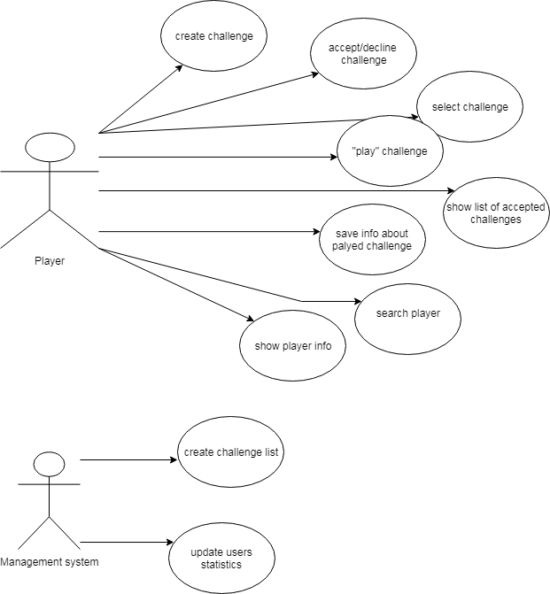

1. **User profile and ranking**

Statistics and ranking of a user.

* 1. **Epics and User Stories**

**Epic:** As a User I want to be able to see my personal information and edit it. I want the application to manage my ranking. As a user I also want to manage my playability and administer my board games collection.

**Story listing and acceptance criteria:**

1. As a User I want to be able to see my current statistics and ranking so I can see my ranking position and level:
   * User can check his current statistics,
   * User can see his current level,
   * User can see his current ranking position,
   * User can see the history of his previous games.
2. As a User I want to be able to find out more about board games that I own and edit my collection:
   * User can see his games collection,
   * User can remove a game from his collection,
   * User can add new game to his collection by selecting it from a list of already existing games or adding a new one to the system.
3. As a User I want to be able to modify my user profile, so that I can change my first name, last name, email, password, and life motto:
   * User can check his current profile information,
   * User can edit all the information about his profile and save it.
4. As a user I want to manage my playability:
   * User can add his availability hours,
   * User can edit his availability hours,
   * User can delete his availability period and make a comment about it (e. g. when someone was interested to play at this particular period),
   * User can see a list of Users with similar availability hours, and automatically create a challenge for those Users.
   1. **Use Case Overview and Use Case specification**

